# Docker Starting with Basic php webpage

Create Dockerfile in your PHP project

FROM php:7.0-apache <is the image file will get downloaded from >

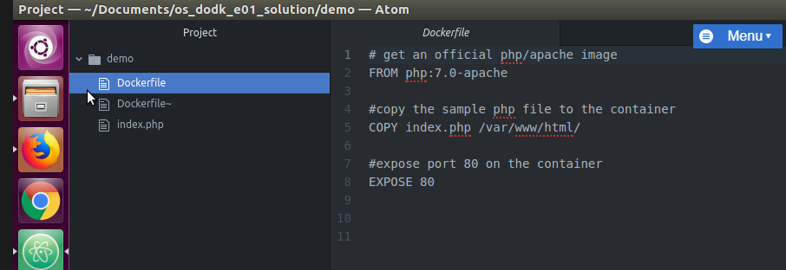

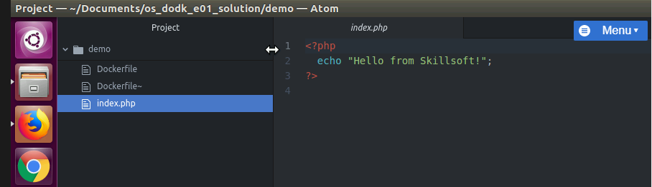



Building Docker named demo. Download the image from internet -

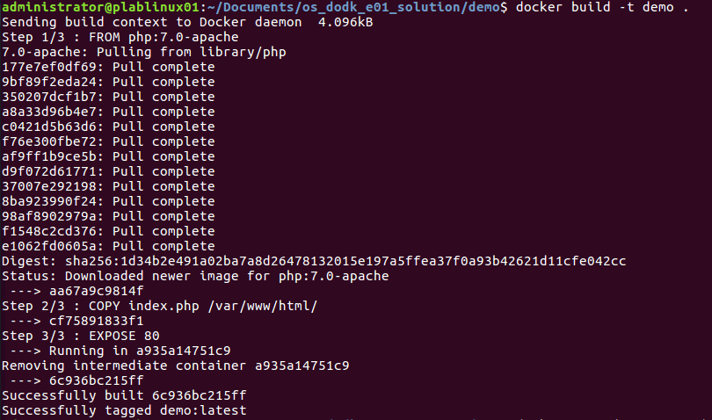

To view the images that got downloaded user command

